Welcome to Defender, the ultimate simulation of the chaos and choices that human beings experience in their life…except done in space with a bunch of b@$st@rdized aliens and a mega-powerful star ship. Cool isn’t it….

And what you will discover is that the inventors of this game (two of them fondly dubbed the Vid Kidz for their Robotron work 2 years later) were masters of risk/reward psychology and a wicked sense of humor that twists up the human nature of fight or flight…make the obvious choice and your ship will soon explode…guaranteed.

This is a game that can’t be learned quickly, takes decades to master, and is best done with the assistance of friends. Eventually, you will step away from the control panel and study the masters such as
- Doug Mahugh’s Defender Manual- THIS IS GROUND ZERO! - http://mahugh.com/defender-the-last-word/
- Paul Spriggs is an extreme master takes us to the beginning- https://www.youtube.com/watch?v=HxCBy1XfdFk
- Gary Whittingham is an extreme master who shows you 256 waves of training strategy- https://www.youtube.com/watch?v=EhtcoADtd9s&feature

THE KILLING FIELD (like the main area of play on a soccer field)
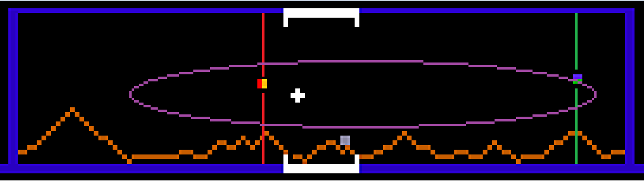
But hey we all have attention deficit in 2014, so what are the basics so you can start dropping credits and getting your knuckles sweaty?!?!?!?!
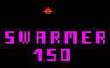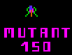
The radar image above shows the area where the player spends most time in the “killing field.” By navigating back and forth you will create “safe areas” of space where you can kill and herd the enemy on YOUR pace, not theirs. Any time the player is put on the defensive, you’ll typically die…they didn’t earn a billion dollars in quarters by making an easy game. Remember that. Put the odds in your favor with wise and clever offense or YOU DIE. PERIOD.

The red and green lines are really neat bits of programming the Defender universe. You will soon discover that when you are being chased by mutants or swarmers, the swarmers/reds won’t cross the red line. The mutants won’t cross the green line. Whew! And during the wave as you navigate back and forth on the killing field, there will be a natural tendency for mutants and swarmers to group up on the planet…which can give you a huge break in the action if used wisely.

THE START OF THE WAVE

It’s all about the pods, the pods, not dirty bombings….

At the start of a wave you need to see how the 4 pods were randomly setup. Can you bomb all 4 on the screen easily? If you can only get one or two….don’t waste the smartbomb. And DO NOT shoot at them to open up the swarmer mess. If you die during the wave, you’ll get another chance at getting a good random setup to possibly bomb all 4 at once! And noob’s die frequently, you’ll get another go at them more than likely.

PROTECTING THE HUMANOIDS, OR LET EM DIE.
Upon bombing the pods, you need to quickly assess if have plenty of humanoids or just that last precious guy before the hellish gauntlet of space…noobs die in space!

If you are down to the last human, while the pod explosion is happening and the screen is slow…blast your way over to the screen where the humanoid exists. Then do whatever it takes to protect him or pick him up.

If you have plenty of humanoids, get yourself a safe screen cleared out in the killing zone so you can manage the aliens with grace and finesse…yah right. Do NOT get panicked by the sound of humanoids being picked up if they are in a screen filled with a mix of aliens. And do not try to save a random humanoid being picked up unless the alien mix on the screen is safe to allow it. Trying to save humans amongst chaos kills noobs.

LANDERS…the guys you will cuss at the most.
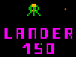
Don’t be fooled by their slow pace or seemingly low IQ. They are gifted with accurate leathal shots that can and will kill you frequently.
TIP- keep as far away from them on the screen as possible, try to shoot them as they appear on edge of screen.
Do not THRUST at a lander or go at full speed as their accurate shots will land right where you are moving. Trust me, they are leathal.
Try to take them out as your first priority in the wave by patrolling the killing zone, unless circumstances change the priorities such as a Mutant coming in hot.

BOMBERS

Typically left toward the end of the wave to help ward off a fleet of angry baiters from descending upon you. If you leave at least 4 enemies to the end of the wave, you’ll not be inundated with lots of baiters. A very important strategy.

TIP- bombers will ignore you and traverse their path unless you shoot at them, they have the ability to slow down to avoid getting hit…so in a way you can control their movement with your laser.

MUTANTS
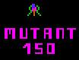
On difficulty 18=0, 19-1 (ie 0-1) the noob should take the time to get used to these enemies, so don’t worry about picking up all humanoids in a panic.
Tip- mutants will always behave in this manner, they will try to get directly above or below the ship, then go vertically to get you.
Tip- they are easiest to kill if you are at top of screen and firing fast, they will bump into the laser.
Tip- navigating back and forth in the killing zone and being mindful of the mutant line to the left of the big mountain will help give you breathing room from them.
Tip- make mutants a priority to kill when they appear in the killing zone.

SWARMERS
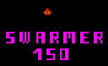
Only fight these guys alone, otherwise stay away from them and use the swarmer line to keep them out of your killing zone.
They are beasts when fought head on as they have a greatly accurate shot pattern.
The trick is to lure them to pass you by, then quick reverse on them. They can’t see you if you are following closely behind so you can shoot em in the back. And cowardly behavior is highly rewarded in Defender….those sneaky programmers and their evil ways!

NEVER, NEVER, NEVER get in a situation where you are trying to fight swarmers and mutants on the same screen. If you can’t get out of it you better be deciding between a smart bomb and hyperspace.

THE BIG MOUNTAIN
The change in altitude of the landers over this obstacle can be a benefit or hindrance.
In general try not to cross it unless there is a strategic reason or it is clear of aliens.
If you are patrolling the killing field, you’ll find that swarmers seem to congregate around the big mountain….if you have some extra smartbombs saved up it is an idea to go over and bomb them all at once…it’ll free up the wave of their pressure so you might have better chances of survival.

SMARTBOMBS OR HYPERSPACE
Keeping the bonus setting at 10k means you have to be careful and conservative in using more than one smart bomb per wave.
If you get in a bad situation with multiple enemies, or get pressed by a bunch of baiters…you have to quickly decide if you have spare smartbombs to waste before your next score bonus hits….or if it is time to hit hyperspace and take your chances on regrouping an attack. If you have spare smartbombs and using it will clear out a nice safe screen space in which to work at killing enemies, then it is probably a wise choice.
The master BJC once said that it is pointless to end your game with a stockpile of smartbombs!
This is one of the noob skills that has to become a personal and internalize skill.

BAITERS…descendants of the lil b@$t@rd UFO’s in Asteroids
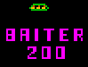
These guys are brutal but you have two bits of control over them.
If you do NOT thrust they can’t see you and will bumble along a zig zag triangular pattern around the player…which often gives you a clear shot on them.
If you do NOT fire at them, they won’t be ready to sidestep you. Be patient and take that perfectly timed shot…or just go into panic mode and see how the dust settles…probably a pretty ship explosion is my bet.

SPACE
Space happens! So the noob might as well get used to it on easier settings now. It is a part of the game and can’t be avoided.
Tip- don’t waste smartbombs on pods at the beginning of a space wave.
Tip- start out wave by moving left a bit, then move right and do some passes to group up mutants. If you get a good group of mutants built up…SMARTBOMB!
Save the pods and swarmers for the end, using your quick reverse and shoot in the back technique.

SETTINGS
After mucking about 2 years and hitting a plateau, it is the noob author’s suggestion to try this.
Train your reflexes in slow pace.
Try 18=0, 19=1, 10k bonus, 5 wave regeneration. Learn to handle the wave in a methodical and non-panicked or rushed manner.
Fill the scoreboard with solid games of 100k plus scores to consider this step of training complete.
This setting means that wave 4 is difficulty 0, then 5 on are difficulty 1.

Try 18=0, 19-1, 10k bonus, 5 wave regeneration. Learn to handle a bit more chaos without getting panicked into poor choices of fight/flight.
Fill the scoreboard with solid games of wave 10 or more to consider this step of training complete.
This setting meanst that wave 4 starts at difficulty 0, each wave after increments the difficulty by 1 notch until you hit maximum difficult of 99…which would be over wave 100! He he he, only X-Master territory.

Then step up to the plate at 18=5, 19=15 on the red roms. This is the real deal.
It means wave 4 starts at difficulty 5, and each wave progresses until the difficulty tops out at difficulty 15 (wave 20).
Report back to Jim Bowley’s “whanger” thread on WDPU facebook page to join the hunt for hitting 1 million.

GETTING HELP:
Record yourself playing and post on Youtube.
The WDPU master players will offer critique and guidance to get you moving forward.

